15.61: 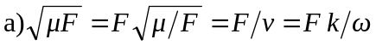and substituting this into Eq. (15.33) gives the result.

b) Quadrupling the tension for F to 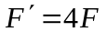increases the speed 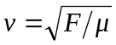 by a factor of 2, so the new frequency 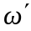and new wave number 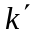are related to 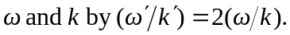 For the average power to be the same, we must have .

Multiplying the first and second equations together gives

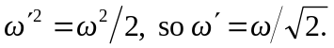

Thus, the frequency must decrease by a factor of 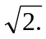 Dividing the second equation by the first equation gives

